~Build a SOHO Network:
- Draw a network diagram for a small office/home office (SOHO) setup that includes: one broadband internet connection, one Wi-Fi router, two laptops, one smart TV, and one printer. Clearly label each device and connection type (wired or wireless).
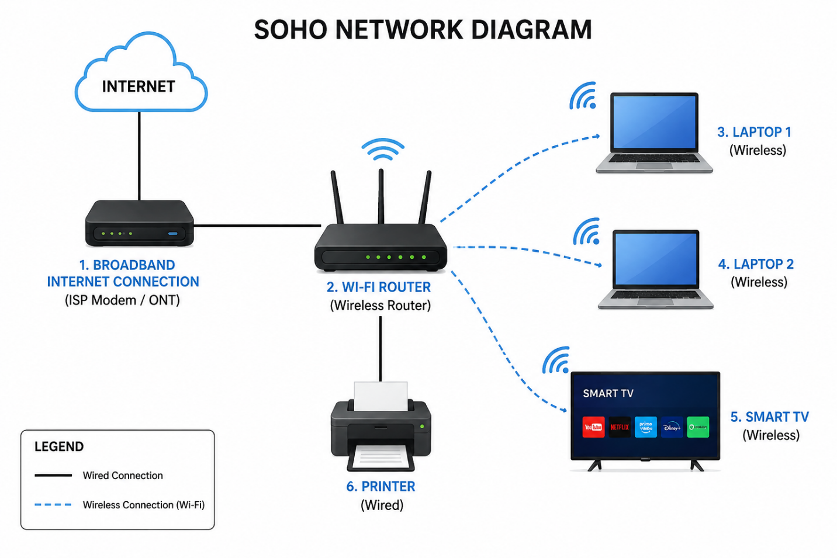

Scenario: Small Office/Home Office (SOHO) Network
A small home office has one broadband Internet connection provided by an Internet Service Provider (ISP). The broadband connection is connected to a Wi-Fi router, which distributes Internet access throughout the office.
- Laptop 1 is connected to the Wi-Fi router wirelessly (Wi-Fi) and is used by the office owner for emails, video meetings, and office work.
- Laptop 2 is also connected wirelessly (Wi-Fi) and is used by another family member or employee for browsing, online learning, and document editing.
- A Smart TV connects to the Wi-Fi router wirelessly (Wi-Fi) to stream YouTube, Netflix, and other online content.
- A Printer is connected to the Wi-Fi router using a wired Ethernet cable, allowing both laptops to print documents over the network.
- The Wi-Fi router manages all network traffic, assigns IP addresses to connected devices, and provides secure Internet access.
Connection Summary:
Device | Connection Type
Broadband Internet → Wi-Fi Router | Wired (Ethernet/Fiber)
Wi-Fi Router → Laptop 1 | Wireless (Wi-Fi)
Wi-Fi Router → Laptop 2 | Wireless (Wi-Fi)
Wi-Fi Router → Smart TV | Wireless (Wi-Fi)
Wi-Fi Router → Printer | Wired (Ethernet

- List all the hardware components (with brand/model suggestions) you would need to physically build the SOHO network diagrammed above, including cables and any switches or extenders if needed.<br><br><em><strong>Hint:</strong> Check current listings on Flipkart or Amazon for typical device models used in Indian homes/offices.</em>
For the SOHO network shown in the diagram, the following hardware components are required. These are common models available on Amazon India and Flipkart:
- Broadband Internet Connection (ISP ONT/Modem) – JioFiber ONT / Airtel Xstream Fiber ONT / BSNL FTTH ONT – Connects the home or office to the Internet.
- Wi-Fi Router – TP-Link Archer C6 / Tenda AC10 – Distributes Internet to all wired and wireless devices.
- Laptop 1 – HP 15s / Dell Inspiron 15 – Used for office work, browsing, and online meetings.
- Laptop 2 – Lenovo IdeaPad Slim 3 / ASUS VivoBook 15 – Used by another user for work or study.
- Smart TV – Samsung Crystal UHD / LG UHD AI ThinQ – Used for streaming videos and presentations.
- Printer – HP Smart Tank 580 / Canon PIXMA G3770 – Prints documents over the network.
- Cat6 Ethernet Cable (2–3 pcs) – D-Link Cat6 / Sounce Cat6 – Connects the ONT to the router and the router to the printer.
- RJ-45 Connectors (Optional) – D-Link / Goldmedal Cat6 RJ-45 Plugs – Used if making custom Ethernet cables.
- Power Adapters – Supplied with each device – Provide power to the router, ONT, printer, and other devices.
- Extension Board / Surge Protector – Belkin / GM / Anchor – Safely powers multiple devices from one outlet.
- 5-Port Gigabit Switch (Optional) – TP-Link LS1005G / D-Link DGS-1005A – Adds extra wired Ethernet ports if needed.
- Wi-Fi Range Extender (Optional) – TP-Link RE205 AC750 – Extends Wi-Fi coverage to areas with weak signal.
- UPS (Optional) – APC 600VA / Zebronics UPS – Keeps the router and ONT running during power outages.

- Write step-by-step instructions to configure the Wi-Fi router for your SOHO network, including setting up a unique SSID, enabling WPA2 security, and changing the default admin password.

Step-by-Step Instructions to Configure a Wi-Fi Router for a SOHO Network:
Step 1: Connect the broadband modem/ONT to the router's WAN/Internet port using an Ethernet cable.
Step 2: Turn on the modem and Wi-Fi router and wait until the Internet and Wi-Fi LEDs become stable.
Step 3: Connect your laptop to the router using a Wi-Fi connection or an Ethernet cable.
Step 4: Open a web browser and enter the router's default IP address (such as 192.168.0.1 or 192.168.1.1).
Step 5: Log in using the default administrator username and password (printed on the router label or in the user manual).
Step 6: Go to the Wireless Settings or Wi-Fi Settings menu.
Step 7: Change the default SSID (Wi-Fi Name) to a unique name (e.g., Manthan_SOHO_Network).
Step 8: Select WPA2-PSK (AES) as the Wi-Fi security mode.
Step 9: Create a strong Wi-Fi password using at least 12 characters with uppercase letters, lowercase letters, numbers, and symbols.
Step 10: Save the wireless settings and allow the router to restart if required.
Step 11: Open the Administration, System, or Management settings.
Step 12: Change the default administrator password to a strong, unique password.
Step 13: Save the changes and log in again using the new administrator password.
Step 14: Reconnect all devices (laptops, smart TV, and printer) using the new SSID and Wi-Fi password.
Step 15: Test the Internet connection on all devices to ensure the SOHO network is working correctly.

- Configure IP addresses for all devices in your SOHO network: assign static IPs to the printer and smart TV, and use DHCP for the laptops. Show a table listing each device, its MAC address (make one up), and the assigned IP address.
SOHO Network IP Address Configuration
Network: 192.168.1.0/24
Router (Gateway): 192.168.1.1
DHCP Range: 192.168.1.100 – 192.168.1.200

Device | MAC Address (Example) | IP Assignment | Assigned IP Address
Wi-Fi Router | 00:1A:2B:3C:4D:01 | Static (Gateway) | 192.168.1.1
Laptop 1 | 8C:AA:B5:12:34:56 | DHCP | 192.168.1.100
Laptop 2 | 9D:BB:C6:23:45:67 | DHCP | 192.168.1.101
Smart TV | A4:5E:60:78:9A:BC | Static | 192.168.1.10
Printer | B8:27:EB:CD:EF:12 | Static | 192.168.1.20
Configuration Summary
- Router IP: 192.168.1.1
- Subnet Mask: 255.255.255.0
- Default Gateway: 192.168.1.1
- DHCP Enabled: Yes (Range: 192.168.1.100 – 192.168.1.200)
- Static IPs: Printer (192.168.1.20), Smart TV (192.168.1.10)
- DHCP Devices: Laptop 1 (192.168.1.100), Laptop 2 (192.168.1.101)
- Explain how you would troubleshoot if one of the laptops cannot connect to the internet in your SOHO network. List at least 3 possible causes and what steps you would take to diagnose and fix each issue.

Troubleshooting a Laptop That Cannot Connect to the Internet in a SOHO Network:
Issue 1: Wi-Fi is Disabled or Wrong Wi-Fi Password
Cause: The laptop's Wi-Fi is turned off or an incorrect password was entered.
Steps to Fix:
- Check that Wi-Fi is enabled on the laptop.
- Make sure the laptop is connected to the correct SSID.
- Re-enter the correct Wi-Fi password.
- Disconnect and reconnect to the network.

Issue 2: IP Address Not Assigned (DHCP Problem)
Cause: The laptop did not receive a valid IP address from the router.
Steps to Fix:
- Open Command Prompt and type ipconfig.
- Check if the IP address is valid (e.g., 192.168.1.x).
- If the IP is 169.254.x.x, renew it using:
  - ipconfig /release
  - ipconfig /renew
- Restart the router if necessary.

Issue 3: Router or Internet Connection Problem
Cause: The router is not connected to the Internet or the ISP connection is down.
Steps to Fix:
- Check the router's Internet/WAN LED.
- Test Internet access on another device.
- Restart the modem and router.
- If no devices have Internet access, contact the Internet Service Provider (ISP).

Additional Checks
- Restart the laptop.
- Run the Windows Network Troubleshooter.
- Update or reinstall the Wi-Fi network driver.
- Temporarily disable the firewall or antivirus to check if it is blocking the connection.
- Test connectivity by running ping 192.168.1.1 (router) and ping 8.8.8.8 (Internet) in Command Prompt.
These steps help identify whether the problem is caused by the laptop, the router, or the Internet connection.

THE END…….

